Keeping the power on: our future energy technology mix

An energy security and net zero committee inquiry

techUK response

August 2023

About techUK
techUK is a membership organisation launched in 2013 to champion the technology sector and prepare and empower the UK for what comes next, delivering a better future for people, society, the economy, and the planet. It is the UK’s leading technology membership organisation, with more than 1,000 members spread across the UK. We are a network that enables our members to learn from each other and grow in a way which contributes to the country both socially and economically. By working collaboratively with government and others, we provide expert guidance and insight for our members and stakeholders about how to prepare for the future, anticipate change and realise the positive potential of technology in a fast-moving world.

Smart Infrastructure and Systems Programme
Our Smart Infrastructure and Systems Programme is the champion for smart infrastructure deployment and governance in the UK, and the economic and societal benefits that smart technologies can deliver. We focus on the innovative application of emerging technologies to traditional forms of infrastructure (such as mobility, energy, water, and the connected home), bringing expert communities together to consider how to reduce costs, increase efficiency and resilience, and deliver better performance.

Smart Energy and Utilities Group

The Smart Energy and Utilities Programme provides a strong platform of technological solutions in support of delivering a competitive, dynamic, and flexible market. The aim of the programme is to provide leadership in emerging technologies and innovation benefits with a focus on decarbonisation, affordability, accessibility, and reliability.

Call for Evidence

Questions:

- Is the energy sector open enough to new generation technology?
- Does the Government sufficiently support development of innovative energy infrastructure?
- Is the Governments plan for energy security sufficiently long term?
- What current technologies could usefully be deployed at scale to deliver better energy security in the UK?
- Are there technologies that have not been able to develop their potential and should be abandoned?
- What energy generation mix will get us to net zero the quickest in the most affordable way?
- Are the energy solutions universal across the UK or are there regional and local approaches on fuel and energy?

Introduction
techUK appreciates the opportunity to contribute to the committee inquiry on how to match energy demand with significant supply and the value of a flexible energy system. As a representative of the technology sector, we recognise the critical role that innovation, policy alignment, and strategic planning play in achieving a sustainable and reliable energy future. Our response is structured around key themes that emerged from feedback from techUK members.
UK’s tech Sector
The UK has established itself as a leading tech economy, with a strong digital sector and globally leading research and start-up ecosystem. The tech sector is one of the UK’s modern economic success stories, with its contribution to the economy rising over 25% between 2010 and 2019, and now adding £150 billion to the economy every year.
This makes it one of the country’s most valuable economic assets and the leading tech sector in Europe. However, our success must not breed complacency. There is now a fierce global race over the key technologies that will shape the future: from AI and Quantum to green technologies and semiconductors, competition between governments to attract talent, bring in investment and grow tech clusters is greater than ever. If the next Government does not make the most of the UK’s strengths, there is a real risk of it falling behind.
Technology is often perceived as a standalone sector; however, government needs to understand that to become a competitive economy we must apply this thinking down to each of our infrastructure sectors, in particular our energy system and utilise longstanding expertise within the UK.
System Approach and Strategic Policy
The energy landscape is intricate and interconnected, involving various components such as generation, transmission, distribution, demand side management, and more. To effectively match energy demand with supply, it's essential to adopt a holistic system approach. This approach emphasises the need for a comprehensive energy strategy that takes into account various vectors, including transport, heat, and local variations.
Focusing on “How” to Deliver Energy
techUK members highlighted the importance of shifting focus from “what” technologies to adopt to “how” these technologies are integrated and deployed. The successful implementation of innovations requires a clear delivery plan that outlines the steps, regulatory measures, and enabling conditions necessary to bring these technologies to market and achieve commercialisation, with the associated benefits for the UK economy. A strategic policy statement, combined with a collaborative approach between government, industry, and investors, is vital to bridge the gap between innovation and deployment.
techUK members are in agreement that we should not be picking ‘winners’ and ‘losers’ when it comes down to our technology mix. It is not just the generation mix that is important but crucial part of getting our economics at scale right is getting generation at the right place and at the right time.

Certainty and Clarity
A consistent concern expressed by techUK members is the lack of certainty and a clear roadmap for the energy transition. Achieving a flexible and resilient energy system requires a long-term strategy that provides a roadmap for both innovation and commercialisation. Certainty is a key driver for attracting investments, and therefore, strategic planning and transparent decision-making criteria are essential for ensuring investor confidence.
Innovation Integration and Collaboration
Innovation is essential for addressing energy challenges, but integration and deployment of successful innovations are equally critical. techUK acknowledges that numerous technology solutions required for a flexible energy system exist already. However, effective integration and scaling up are contingent on regulatory measures, market constructs, and industry collaboration. Implementing sandboxes and allowing controlled testing in the market can foster innovation while managing risk, however effective scaling up of innovation and commercialising solutions tested outside of the market is a huge challenge.
We emphasise the significance of digital infrastructure as a fundamental enabler of the energy transition. Digitalisation allows for efficient real time monitoring, predictive analytics, and data driven decision making across the entire energy value chain. The adoption of smart grids, IoT enabled devices, and advanced data analytics empowers utilities to optimise resource allocation, reduce waste, and enhance overall system efficiency.
Accelerating adoption of digital technology can bring forward reductions in greenhouse gas emissions by up to 20% by 2050 in the three highest-emitting sectors: energy, mobility, and materials, according to the World Economic Forum. Data transparency, digital talent and partnerships are critical for companies to rapidly adopt the technologies and realise their net zero ambitions faster.
Case Study – Electralink - a retail digital platform (EMPRIS)
ElectraLink has created a data analytics platform using the data surfaced from the data trust of the DTS. EMPRIS empowers multiple parties and users to bring their skills and understanding of the UK energy market to interrogate raw energy data and generate new insights into the market. With EMPRIS, ElectraLink is reproducing the data that underpins the retail energy market and making it available in a granular, pseudonymised format.
EMPRIS’s innovative technology makes energy data more visible for the benefit of all market participants and consumers. Users are empowered with secure and instant access to data about energy production and consumption through self-serve analytics to improve the understanding and outcomes of policy, reduce the burden of reporting on the industry, and drive the energy market transition. ElectraLink has rolled out this platform to Ofgem and DESNZ, who are using the platform to understand market trends including switching.
Our successes with EMPRIS show that data and digitalisation can help inform and improve the wider policy making environment.
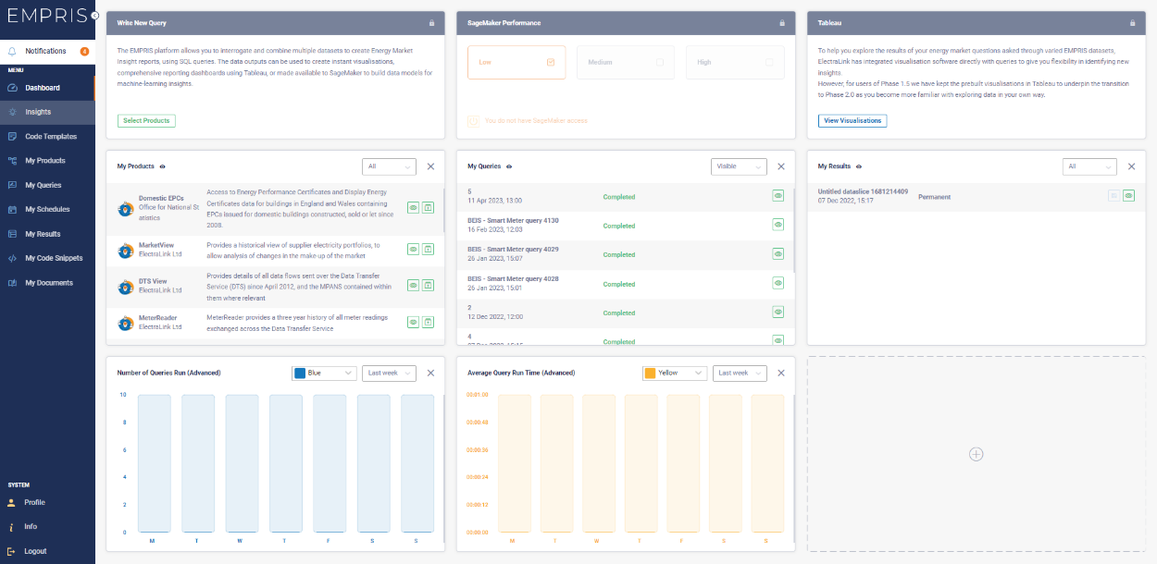

EMPRIS platform provides the energy sector with the following capabilities:
- Access to the DTS Data Trust covering settlement, switching and meter installation data.  - GB-wide retail energy data that will help support independent analysis of the GB Energy Market or individual retailer operations.  - User-friendly, visual, and adaptable dashboards that allow users to analysis GB data and develop insights.  - Access to aggregated and disaggregated retail energy data (dependent on permissions)  - Highly secure cloud-based design that is fully scalable to manage billions of rows of data. | - Robust governance, policy, permission rule and safeguards that are compliant with all data privacy rules based on 25 years’ experience in managing the DTS and data access.  - Standardised, interoperable approach for data across energy including Dublin Core and current industry best practices.  - Securely manage sensitive data to ensure full compliance with data privacy rules and adaptable to meet future needs.  - Considered, configurable and controlled user-centric access for all energy participants, ensuring data is accessed by those with the correct permissions.

Local and Regional Variations
Energy solutions must be tailored to local and regional needs and assets. While national strategies are crucial, local planning and understanding are equally important. A combination of national and localised efforts will lead to more effective energy generation, distribution, and consumption patterns.
We want to point out the huge value of local and regional types of generation, which is also consistent with local energy planning. Taking advantage of what solutions are there locally and how to best exploit them at the right time will be crucial.

Case Study – Octopus Energy – “Zero Bills”
Octopus Energy’s Octopus Zero, a first-of-its-kind energy tariff providing zero bills for five years, guaranteed, is a prime example of that. Domestic heating is currently responsible for 14% of the UK’s total carbon emissions alone, and Zero Bills represents a step to net zero.
More work on new homes will also support the roadmap to net zero. Down the line, homes which have incorporated battery storage, solar panels, and electric heating could benefit from using cutting-edge tech to optimise the household’s consumption and energy export in exchange for a zero bill.
PwC estimate that a place-based approach to the energy transition could unlock £108 billion of savings on consumer bills for an investment of £58 billion.

Energy storage, including battery technologies and vehicle-to-grid solutions, is a cornerstone of a flexible energy system. While energy storage solutions are becoming available, challenges in commercialisation, standardisation, and integration remain. There's a need to address these barriers to ensure that storage solutions contribute effectively to energy security and grid stability.
Policy and Regulation
Effective policy and regulation are key enablers for a successful energy transition and should be considered as an integral part of the much talked about “Whole System Approaches”. Regulatory measures should focus on creating an environment conducive to innovation, investment, deployment, and collaboration. Clear market constructs, pricing mechanisms, and revenue pathways will drive economic viability and encourage private sector investments.
Policy development must be also coherent with infrastructure development and coordination with other government departments. Our energy system will incorporate massive amounts of assets on the grid. We are also rapidly creating a digital economy, electrifying heat, and transport. The energy and digital sectors are becoming increasingly intertwined with how we plan for infrastructure, and we need to design our policy accordingly as well.

Conclusion
In conclusion, techUK is deeply committed to driving the UK's transition to a sustainable and reliable energy future. As a prominent representative of the technology sector, we recognise the pivotal role that innovation, policy alignment, and strategic planning play in achieving these goals. Our response to the committee inquiry is a testament to our dedication to creating a robust energy system that effectively matches demand with significant supply while embracing the value of a flexible energy approach.
The UK's tech sector has emerged as a powerhouse of innovation and economic growth, contributing significantly to the nation's prosperity. However, we must not rest on our laurels; the global competition for key technologies necessitates a forward-thinking approach. As we navigate the complexities of energy transformation, we emphasise the need for a system-based perspective that considers various vectors of infrastructure.
Our discussions shed light on the crucial importance of focusing on the "how" of delivering energy solutions. The successful integration of innovative technologies requires a well-defined delivery plan, transparent regulatory measures, and collaboration between stakeholders. Certainty and clarity are cornerstones of investor confidence and long-term planning, ensuring that the UK remains a competitive player on the global stage.
Innovation integration and collaboration are pivotal to realising a flexible energy system. By leveraging digital infrastructure and smart technologies, we can optimise resource allocation, reduce waste, and enhance system efficiency. To harness the full potential of our energy transition, we advocate for a harmonious interplay between policy, infrastructure, and digital transformation.
Digital infrastructure can form the backbone of a resilient energy landscape. Overcoming commercialisation challenges and fostering standardisation will unleash the true potential of storage solutions, contributing to grid stability and energy security. Effective policy and regulation are paramount, creating an environment conducive to innovation, investment, and collaboration. Policy alignment with infrastructure planning is key, considering the intertwined nature of energy and technology sectors.
As techUK, we are committed to leveraging our expertise, resources, and collaborative spirit to support the UK's journey towards a sustainable energy future. By embracing a holistic system approach, driving innovation, and fostering effective collaboration between all stakeholders, including policy makers and regulators. We believe that the UK can emerge as a leader in the global energy transition, setting a benchmark for resilient, efficient, and flexible energy systems.

A UK Tech Plan: How the next Government can use technology to build a better Britain (techuk.org)

